Requirements/Design Specification

**July2015 GH444**

**Display Lifts per week not accurate for existing customers with multiple lifts per day (CR 14085)**

Revision History

|  |  |  |  |
| --- | --- | --- | --- |
| **Date** | **Revision** | **Description** | **Author** |
| 5/18/2015 | 1.0 | Initial Version with Requirements | Gaurav Dawar |
|  |  |  |  |
|  |  |  |  |
|  |  |  |  |
|  |  |  |  |

The information furnished herein by Republic Services Inc. is proprietary and confidential to Republic Services Inc. personnel and is not to be duplicated, published, or disclosed to any third party in whole or in part without permission from Republic Services, Inc.

© Copyright 2012, Republic Services Inc. - All rights reserved.

Table of contents

1 Business Requirements 6

1.1 Purpose of the Design Specification 6

1.1.1 Bug list for current release 6

2 Competitor Overview and Assumptions 6

3 Design 6

4 Impacted Systems (InfoPro, TIBCO and BI) 8

5 Report Changes 8

6 Appendix 8

# Business Requirements

## Purpose of the Design Specification

This document highlights items to be fixed and implemented for the titled release.

### Bug list for current release

| GitHub Item  Number | **Description** |
| --- | --- |
| 444 | Display Lifts per week not accurate for existing customers with multiple lifts per day (CR 14085) |

# Overview and Assumptions

Since the Lifts per period in STR for existing customers I handled as number of days serviced in a week because it takes into consideration the period as well and as per logic the period is not always 1 week if there are more than 1 number of lifts in a particular day of the week i.e. if a customer is serviced every Monday and Thrrsday of the week and on every Monday it is serviced twice then the number of lifts per period is “ 3 x Week” whereas in STR it is shown as “2 x Week” because Period in this case is adjusted from 1 to 1.5 to consider the extra lift on the Monday.

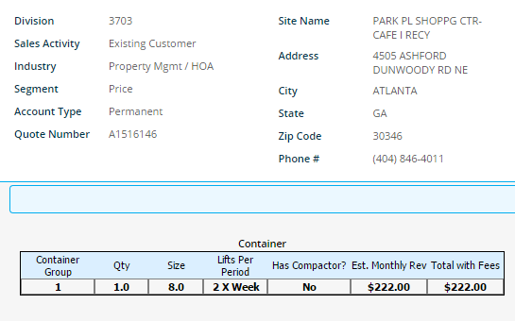

Whereas in the service change it does not take the period in account.

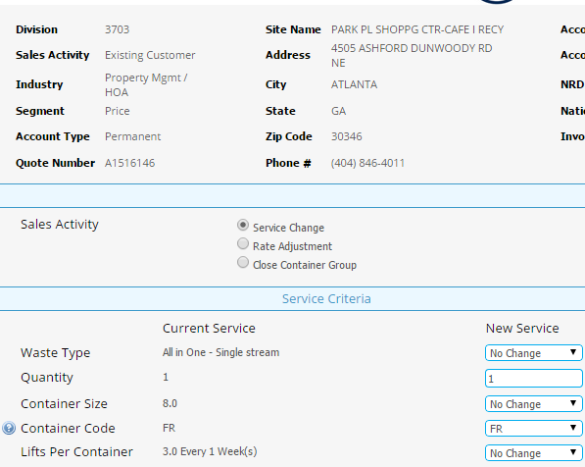

# Design

## #444 Display Lifts per week not accurate for existing customers with multiple lifts per day (CR 14085)

To fix this we have to change the formulas applied to take Period into account after we pull the number of lifts from the account status table in util library function “Get Customer Site Container Groups”.

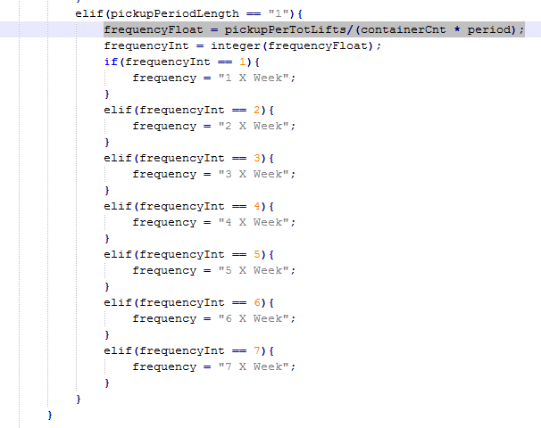

# Impacted Systems (InfoPro, TIBCO and BI)

No new variables are created hence this fix should not affect InfoPro AAE process.

# Report Changes

NA

# Appendix